# FLIGHT RESERVATION SYSTEM

**STEP – 1:**

Go to creator in zoho.com

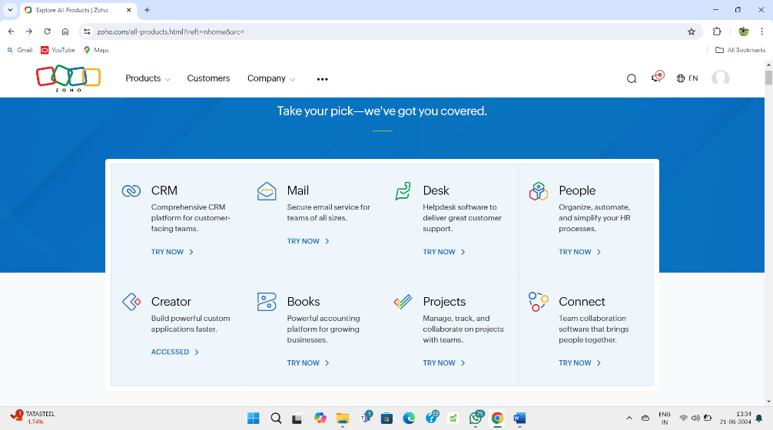

**STEP – 2:**

Create a new application.

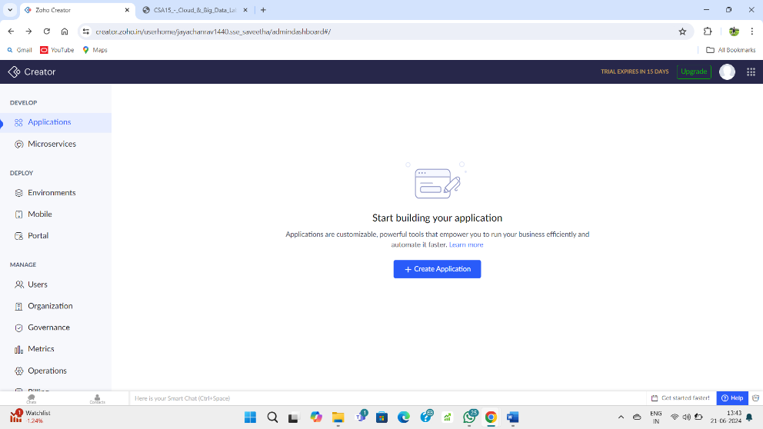

**STEP – 3:**

Select Create application from scratch and name it.

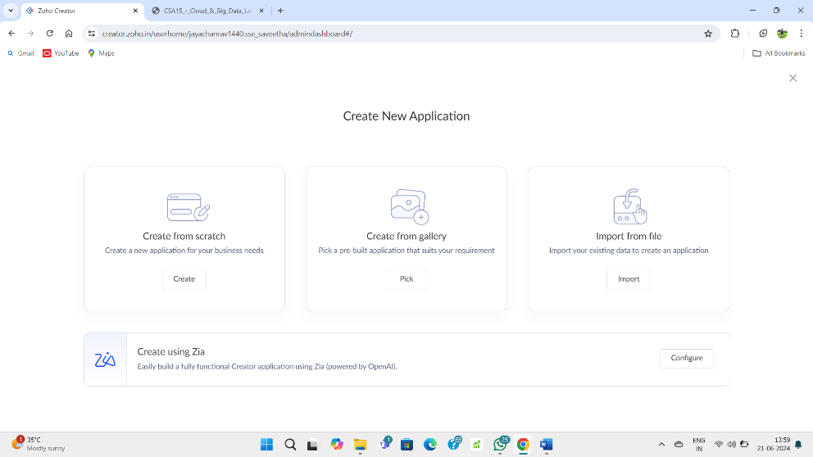

**STEP – 4:**

Create a new form and name it as login form.

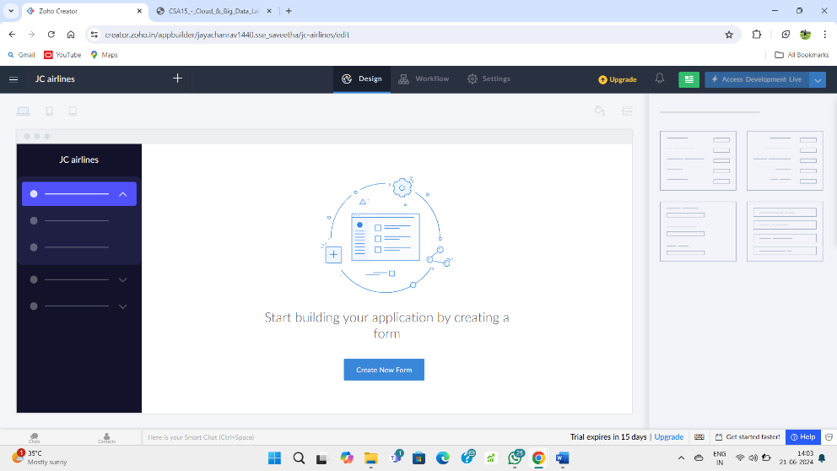

**STEP – 5:**

Create form from scratch.

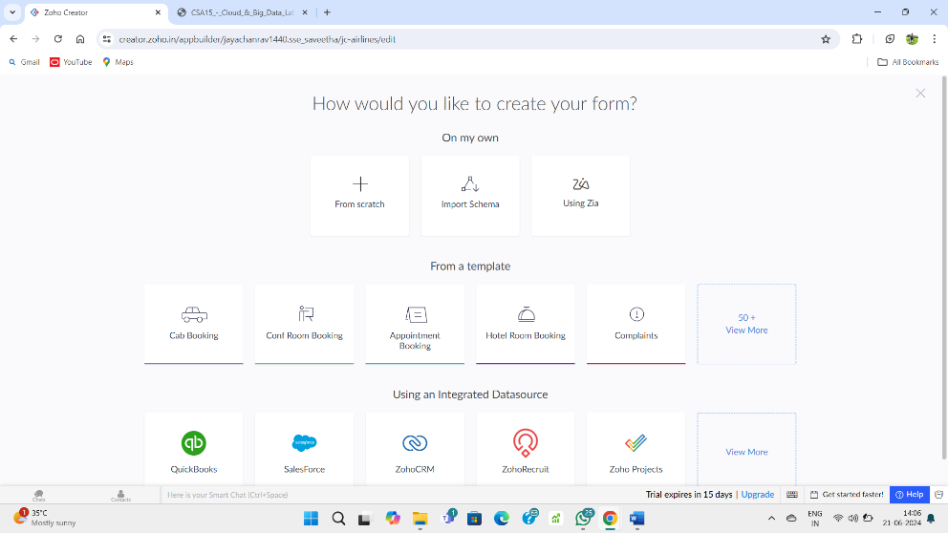

**STEP – 6:**

Create login formand give required fields along with mandatory fields.

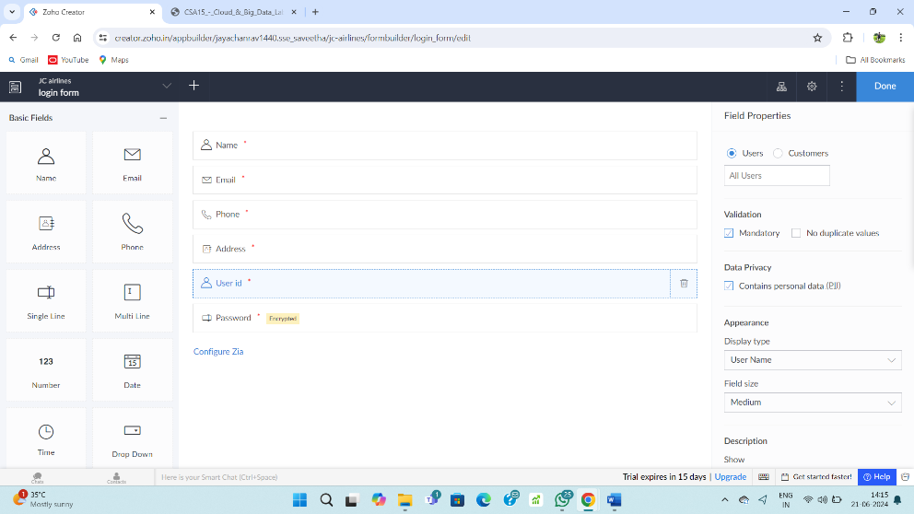

**STEP – 7:**

Fill upon the created form.

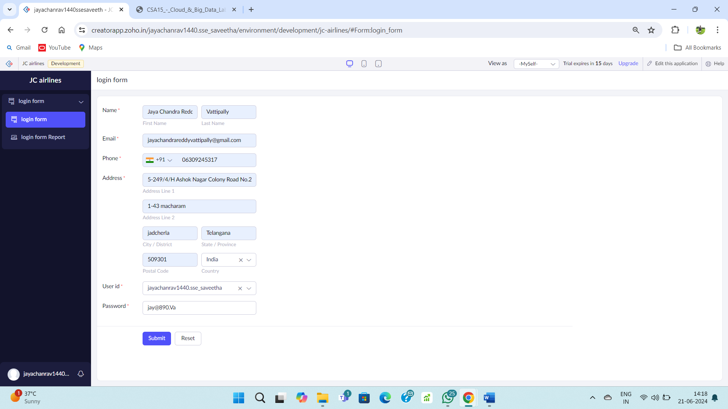

**STEP – 8:**

Go to the login form report to check the details.

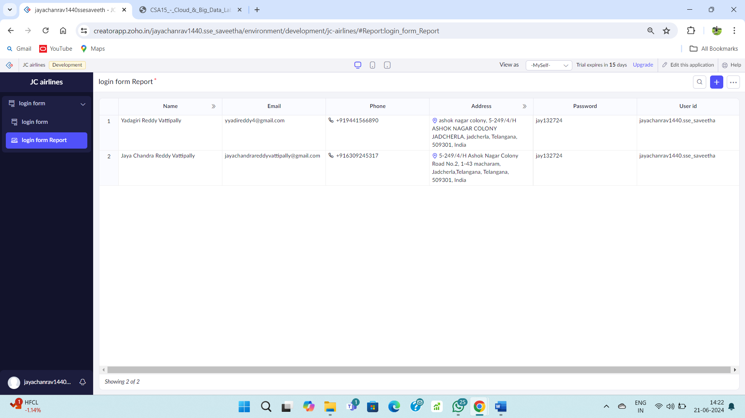

**STEP – 9:**

Create another form named journey details.

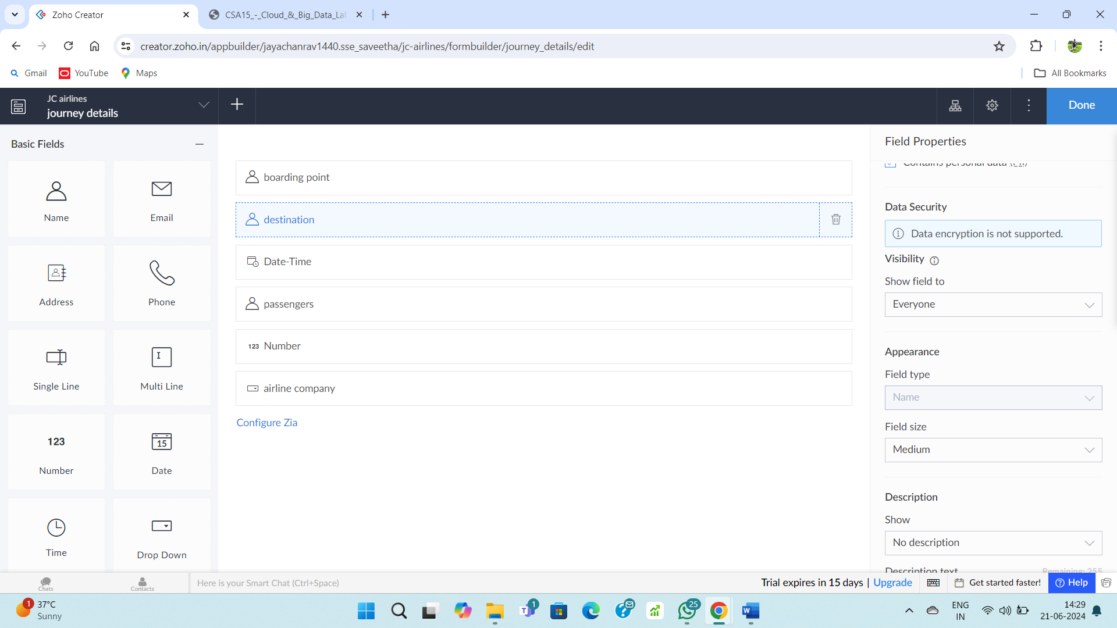

**STEP – 10:**

Fill upon created form.

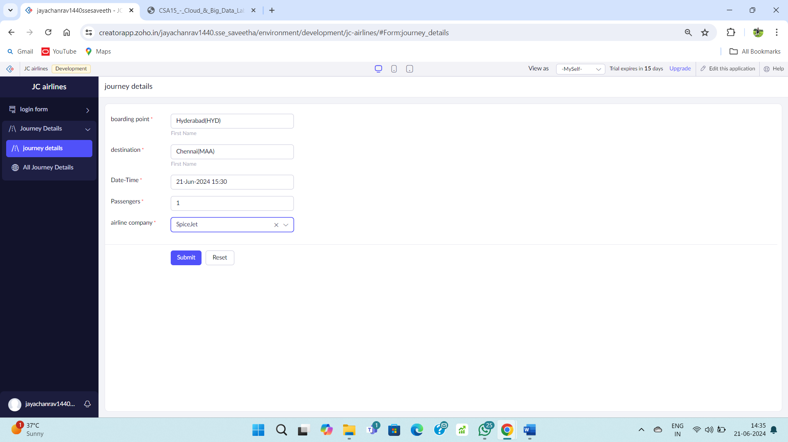

**STEP – 11:**

Go to the journey details report form.

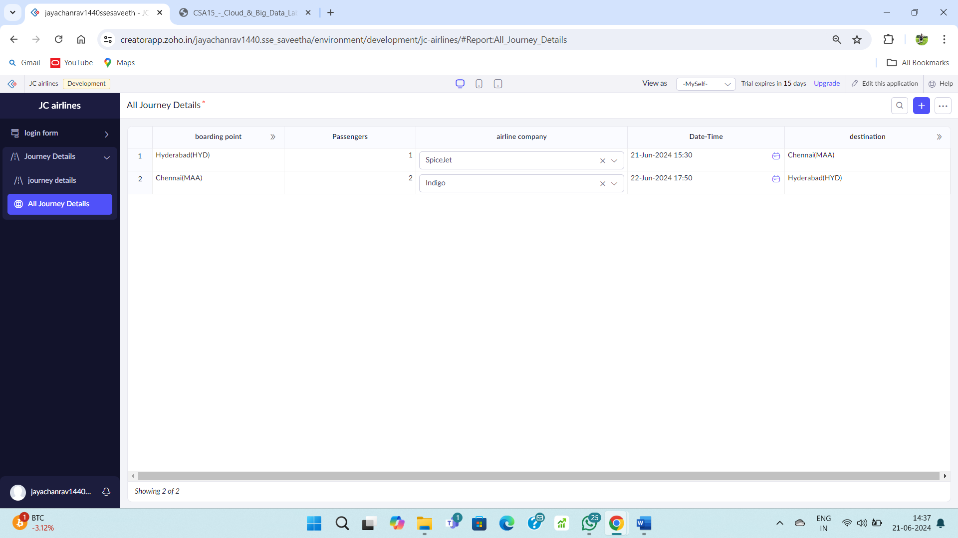

**STEP – 12:**

Create a new form named payment section.

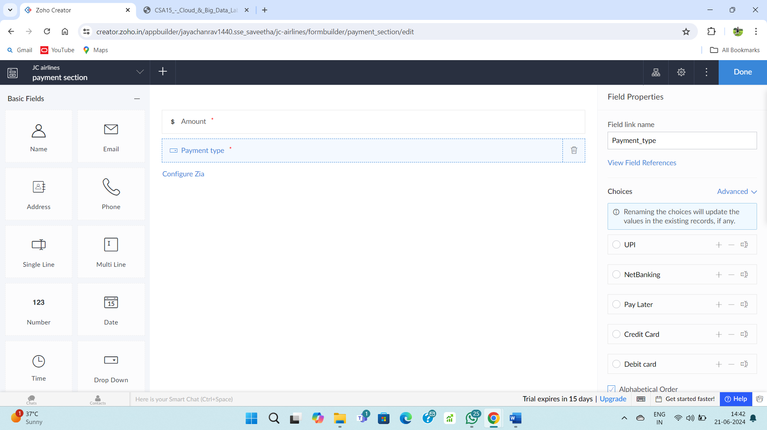

**STEP – 13:**

Fill upon the created form.

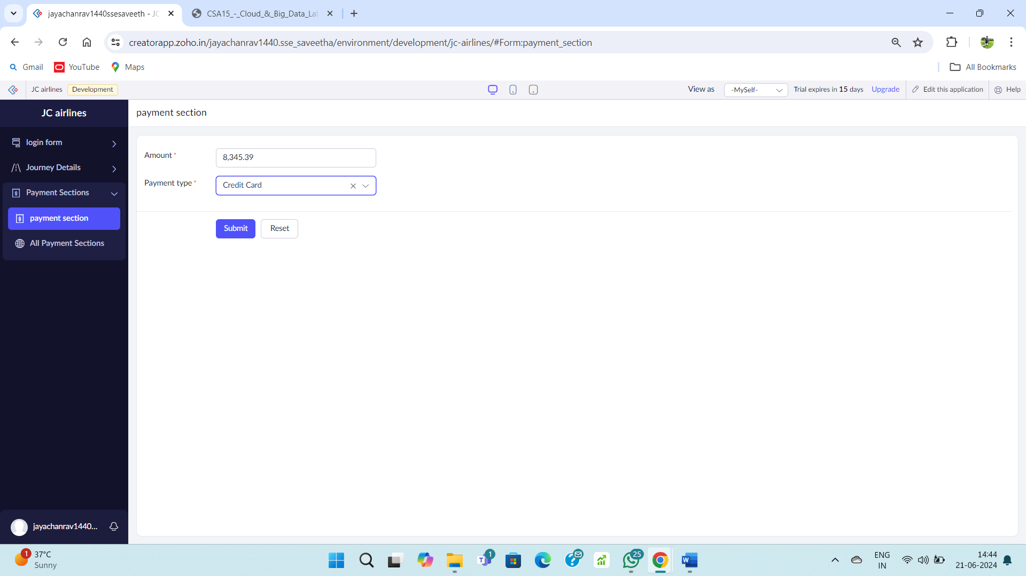

**STEP – 14:**

Go to payment report form.

